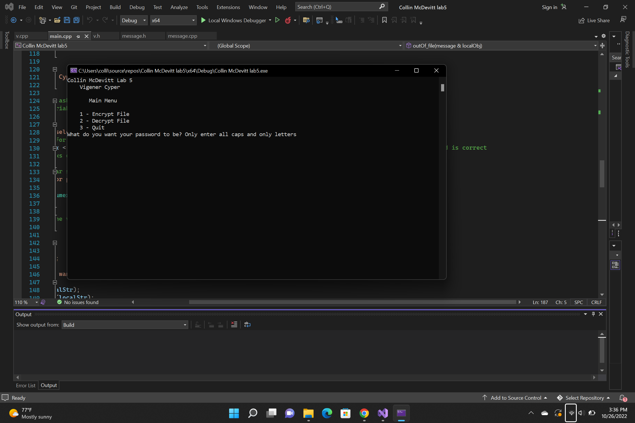

I have not shared the source code in my program with anyone other than my instructor’s approved human sources.

⦁ I have not used source code obtained from another student, or any other unauthorized source, either modified or unmodified.

⦁ If any source code or documentation used in my program was obtained from another source, such as a text book or course notes, that has been clearly noted with a proper citation in the comments of my program.

⦁ I have not knowingly designed this program in such a way as to defeat or interfere with the normal operation of any machine it is graded on or to produce apparently correct results when in fact it does not.

Algorithm

Create the array that will hold the input from the file

Call the function that will print the menu information

Call the function that will ask for the key

Function that asks for key will error check the input

it sets the char to their ASCII values then finds the max and min values and makes sure that they are in the range from 65 to 90

Uses the value that was returned from the key in the constructor of the message object

After object is created it will go into a always true loop and will then clear the vector and then will print the menu again and call a function that is the choice that the user has selected

If they select 1 then it will ask for the name of the file

After getting the name of the file it will attempt to open the file

If it doesn’t open then it will output that it didn’t open and will return back to the menu if it did open then it will use the function that will continue to use getline until the end of file is reached and store it in the char array

After the end of file is reached it will then go through and tokinize the input and encrypt it while it is going through

After it is tokenized it will then ask the user for the name of the file that they want to store the encrypted file in and will then try to open it if it does open then it will output to that file if it does not then it will return tho the main menu again

If the user selects 2 then it will ask for the name of the file that they want to decrypt and then attempt to open it if it does not open then it will return to the main menu

If it does open then it will use the previos function that will read until the end of file is reached

It will store all of it in the vector and then tokinize it all and then will decrypt it

After it will ask for the name of the file that they want to store it in and then will atttempt to open it if it can open then it will output to that file if it does not open then it will tell the user and return to the main menu

If they hit option 3 then it will just break out of the loop